**Decentralized Job Portal Smart Contract**

**A Usecase of Application of Blockchain**

**For Employment**

**Problem Statement:**

Imagine you're someone without advanced job skills looking for work in a new place. It's tough because you don't always know where to find job openings that fit what you can do. So, you might turn to middlemen, like job agencies or contractors, to help you out. But here's the problem: these middlemen often take a big chunk of your salary as payment for their help. It's not fair! We need simpler and fairer ways for people like you to find jobs without having to give away so much of your hard-earned money.

**Solution:**

Blockchain technology offers a better solution for managing job portals, facilitating transparent and secure interactions between employers and job seekers. In this scenario, the roles involved are Employers and Applicants. The following are the features and functions of the job portal smart contract:

**Roles:**

* Employer: Posts job listings and manages the hiring process.
* Applicant: Applies for jobs and manages their application status.

**Features of the Smart Contract:**

1. Post Job:

* Function for employers to post job listings.
* Parameters: Title of the job, job description, required skills, salary offered.

1. Apply for Job:

* Function for applicants to apply for a job.
* Parameters: Job ID.

1. Get Applicant Details:

* Function to retrieve details of an applicant based on their ID.

1. Get Job Details:

* Function to retrieve details of a job based on its ID.

**Recommended Technologies**:

* Smart Contract Development: Solidity
* IDE Tool: Remix
* Blockchain: Ethereum
* Server: Ganache Blockchain

**Project Development Guidelines:**

* Employers post jobs, and manage job listings.
* Applicants can apply for jobs and view job details.
* Proper version control using GitHub.
* Deployment and hosting of the application on a blockchain instance.

**Project outputs:**

Once you deploy the contract using remix IDE, you can see all the below functions:

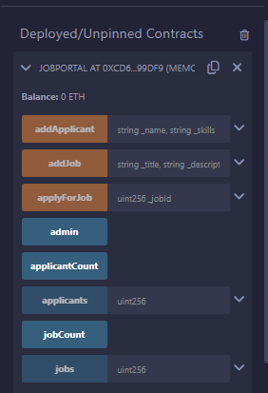

**Function Details:**

Register a new job post of a company:

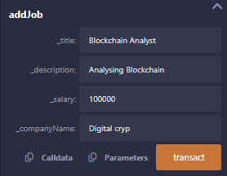

Add a new applicant:

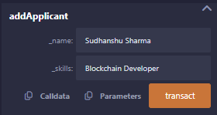

Apply for a job:

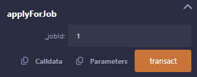

Admin call :



View applicant count:



View applicants :

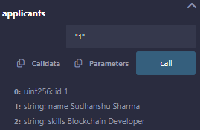

View job count:

C:\Users\LENOVO\Desktop\job count.png

View jobs & its details:

